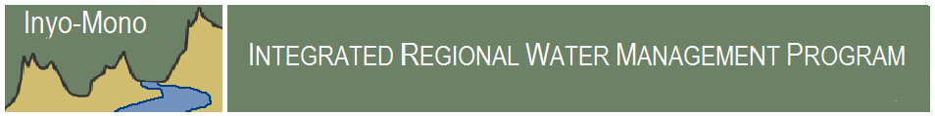

For Immediate Release

Contact: Holly Alpert
Program Manager
Inyo-Mono Integrated Regional Water Management Program
tel. 760-709-2212
email. holly@inyo-monowater.org

Tecopa Water Feasibility Study Complete

January 10, 2014 – The Inyo-Mono Integrated Regional Water Management (IRWM) Program and the Amargosa Conservancy are pleased to announce the completion of the Tecopa Safe Drinking Water and Fire Water Supply Feasibility Study. This project was funded through a Proposition 84 Integrated Regional Water Management Implementation Grant administered by the California Department of Water Resources.

Currently, residents of and visitors to Tecopa, CA, in southeast Inyo County, do not have access to a local source of potable water, nor is there capacity to store water for firefighting. Groundwater sources in the area generally exceed maximum contaminant levels for arsenic, fluoride, and total dissolved solids. Residents and visitors either drink untreated groundwater or purchase water in Pahrump, NV – 30 miles away. In addition, Tecopa is an economically-disadvantaged community, which means its median household income is less than 80% of the California statewide median household income. The Inyo-Mono IRWM Program and the Amargosa Conservancy partnered with Johnson Wright, Inc. of Layfayette, CA, and R.O. Anderson Engineering, Inc. of Minden, NV, to complete an analysis of local water supply and demand, and to develop options for treating and storing water locally for both potable water use and firefighting supply.

Consulting hydrogeologists reviewed available information on Tecopa-area groundwater wells and collected new samples for analysis of various water quality constituents. In addition, the consultants analyzed water demand and use in the area through a questionnaire circulated to local residents and businesses. Results from this survey were used to determine how much drinking water would need to be treated and supplied to the community on a daily and yearly basis. The project consultants also held three community meetings to present parts of the feasibility study and gather feedback from residents and visitors.

Based on results of the various analyses performed, the consultants developed two scenarios for providing local access to drinking water and fire water storage. Both options consist of treating water to drinking water standards at a centralized kiosk located in Tecopa Heights and/or Tecopa Hot Springs where residents and visitors can purchase water at a reasonable rate. The study also includes options for siting storage tanks at both locations for collecting fire water supply. The total cost of constructing the water treatment facility and the two fire water storage tanks is approximately $120,000. The Amargosa Conservancy, in partnership with the Inyo-Mono IRWM Program, is seeking funding to construct the facilities.
Jordan Kelley, the Amargosa Conservancy Executive Director, says of the project, “It's all very exciting, but the fact remains there are towns out here that lack potable water, and we are coming up with innovative ways of creating a sustainable system to service the community. With this project we will bring clean drinking water to the town and also improve fire prevention resources in this desert community.” He expressed the gratitude of the Conservancy to the IRWM Program and the California Department of Water Resources for providing funding to conduct the feasibility study. Mr. Kelley also said the Conservancy is looking forward to assisting the remote, rural community of Tecopa in obtaining the funding necessary to construct these vital community improvements.

A report detailing the methods and results of the feasibility study was released in December 2013 and can be found on the Inyo-Mono IRWM Program website (www.inyo-monowater.org). The Inyo-Mono IRWM Program will continue working with the community of Tecopa to secure funding to build the preferred project and begin making potable water available to the residents and visitors of Tecopa.

Proposition 84 was approved by voters in 2006 to support water supply, water quality, and natural resource protection efforts. This funding was provided through the Inyo-Mono IRWM Program, which has been working to identify water-related needs and secure funding for water projects in the region since 2008. In 2011, the Inyo-Mono IRWMP was awarded a grant of $1,075,000 to fund seven on-the-ground projects that support improvements in water supply and water quality in Inyo and Mono Counties. Other project locations include Coleville, Swall Meadows, Round Valley, Lone Pine, Laws, Independence, Aspendell, and Mammoth Lakes. For more information about the projects, visit http://inyo-monowater.org/inyo-mono-irwm-plan-2/implementation/.

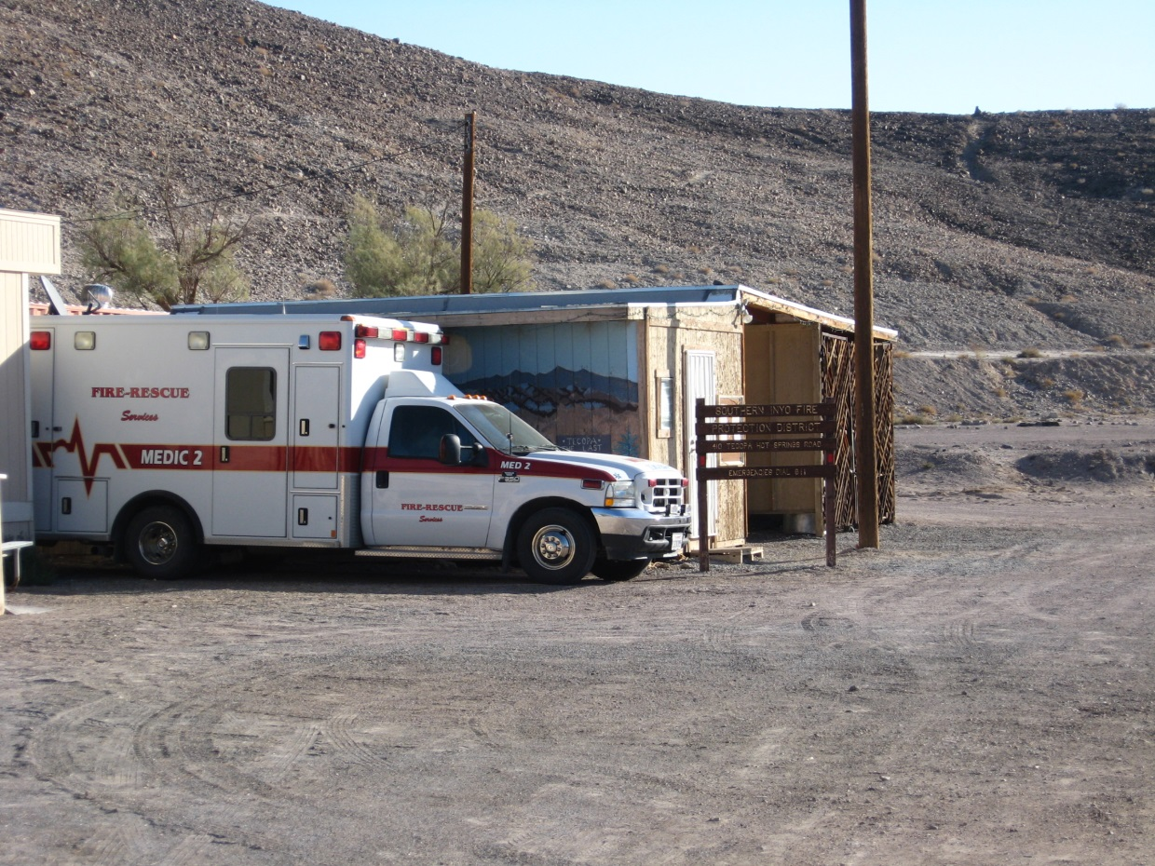
Above: current location of emergency medical services in Tecopa Hot Springs.
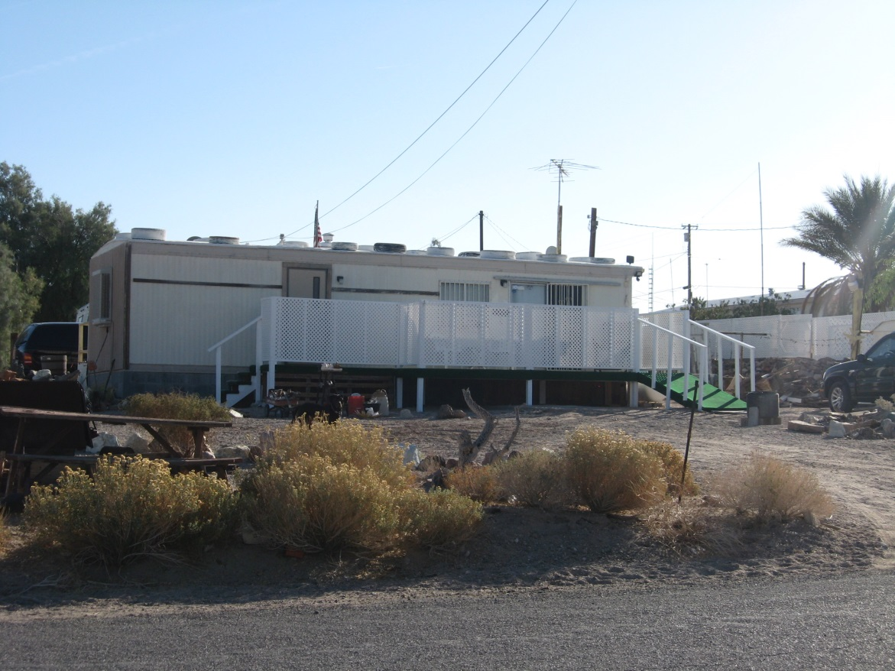
Above: A residence in Tecopa Heights.

