Measuring the Health of
Streams and Rivers in California
College of Bioassessment – 2016 Curriculum
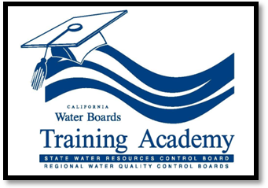
About the College of Bioassessment
Bioassessment in water quality management involves the use of biotic indicators and measures of physical/habitat condition to determine the health of aquatic systems. Development of standardized techniques for measuring the condition of California streams and rivers began in the early 1990s based on guidelines proposed by the U.S. EPA. Over the years, there have been considerable advancements in bioassessment techniques and tools for developing biotic indicators. This work, led by CDFW in cooperation with the State and Regional Water Board’s Surface Water Ambient Monitoring Program (SWAMP), has provided the State Board with the framework necessary to propose the implementation of biological objectives (biocriteria) for wadeable streams.
Water resource managers and others concerned about protecting the health of streams and rivers need to understand the implications of bioassessment data and how it is being collected and used in California. The “College of Bioassessment”, offered through the Water Board’s Training Academy, provides students the necessary training to become competent with administering and conducting a bioassessment project.
About the Curriculum
The 2016 COB curriculum consists of two 3-day courses which combines an introduction to bioassessment and SWAMP field procedures into one course (Combined Couse 1 and 2) and laboratory procedures and data analysis into another course (Combined Course 3 and 4). In past years, these four courses were offered separately, but in 2016 only the combined courses will be available. The courses should be taken in succession and attending both will give the student a beginning understanding on the use of bioassessment by SWAMP and in water quality monitoring and regulation.
About the Instructors
The Principal Instructor for each course offered through the College of Bioassessment is Jim Harrington, a Staff Environmental Scientist with the California Department of Fish and Wildlife. Jim has been working in the field of freshwater bioassessment for more than 30 years. In 1996, Jim developed field and laboratory curriculum for professionals, environmental educators and watershed groups, teaching them the principles of bioassessment and how biological indicators can be used in California water quality monitoring and enforcement. Although Jim will be the principal instructor for the College of Bioassessment, there will be various professionals in the field of bioassessment who will be stepping in to help with some courses or as guest lecturers.
How to Sign Up
Waterboard employees –Self-registration is available through the academy online registration system.
Non-waterboard employees – Send an email to academy@waterboards.ca.gov
with your contact information and the date and location of the classes you would like to attend.

Note: These classes should be taken in order.
If you have special accommodation or language needs, please contact Jami Ferguson at least 5 working days prior to the class at (916) 322-3235 or email jferguson@waterboards.ca.gov TTY/DD/Speech to Speech users may dial 7-1-1 for the California Relay Service.
For questions concerning registration please contact the Waterboards’ Training Academy.
Course Schedule and Locations

Course 1 and 2 Combined Concept of Bioassessment and SWAMP Field Procedures

April 5, 6 and 7, 2016 Costa Mesa
April 19, 20 and 21, 2016 Sacramento/Rancho Cordova
June 21, 22 and 23, 2016 Redding/Anderson

Course 3 and 4 Combined Aquatic Invertebrate Laboratory Procedures and Data Analysis

August 23, 24 and 25, 2016 Costa Mesa
September 13, 14 and 15, 2016 Sacramento
September 27, 28 and 29, 2016 Redding/Anderson

Condensed Course 1-2 - Concepts of Bioassessment and SWAMP Field Procedures
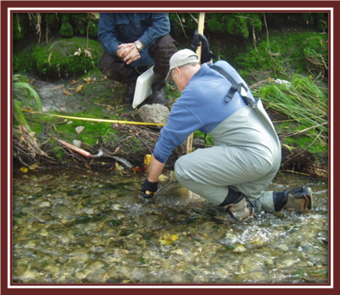
This 3-day field course covers concepts of bioassessment and all aspects of the SWAMP bioassessment protocol from collecting freshwater invertebrate and algae samples to measuring the physical habitat of wadeable streams. The participants will practice various procedures at the stream site following detailed demonstrations by the instructor.

Course Agenda
Day 1 Classroom Instruction
9:00 – 9:30 Introductions and Training Objectives
9:30 – 10:40 Presentation 1 - Overview of Bioassessment
10:40 – 11:00 Break
11:00 – 12:30 Presentation 2 - Stream Ecology, Freshwater Invertebrate Taxonomy and Producing Biological Metrics
12:30 – 1:30 Lunch
1:30 – 2:40 Presentation 3 - Bioassessment Field Sampling
2:40 – 3:00 Break
3:00 – 4:00 Presentation 4 - Sampling Design and Considerations for Using Bioassessment in Water Resource Projects
Day 2 Field Demonstration and Practice
9:00 – 9:30 Introductions and Training Objectives
9:30 – 10:40 Demonstrate Site Delineation and Chemical Sample Collection
10:40 – 11:00 Break
11:00 – 12:30 Demonstrate and Practice Invertebrate and Algae Sample Collection
12:30 – 1:30 Lunch
1:30 – 4:00 Practice Invertebrate and Algal Sample Processing

Day 3 Field Demonstration and Practice
9:00 – 9:30 Review and Questions from Day 1
9:30 – 10:40 Demonstrate Measuring Physical Habitat Transect Parameters
11:00 – 12:30 Practice Measuring Physical Habitat Transect Parameters
12:30 – 1:30 Lunch
1:30 – 2:40 Demonstrate Measuring Physical Habitat Reach-Wide Parameters
2:40 – 3:00 Break
3:00 – 4:00 Practice Physical Habitat Reach-Wide Parameters
Condensed Course 3-4 - Aquatic Invertebrate Laboratory Procedures, Biological Metrics and Data Analysis
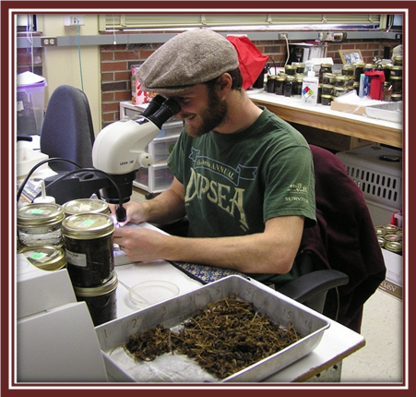
The first two days of this 3-day laboratory/classroom course cover freshwater invertebrate taxonomy and biological metric calculations. The participants will identify invertebrates to the family level from six different sites and produce the data for examining site condition. The last day of this course covers sampling design and data analysis of both ambient and point-source assessments. Excel spreadsheets of taxa lists, biotic metrics and physical habitat elements will be examined by the students to answer a series of questions on data interpretation, quality and variability at actual SWAMP sites. SWAMP templates and data entry/retrieval from the CEDEN database will be presented.
Course Agenda
Day 1 Conference Room and Laboratory
9:00 – 9:00 Introductions, training objectives and description of Course 3 manual
9:30 – 11:00 Presentations on the principles of bioassessment, freshwater invertebrate ecology and sample processing
11:00 – 11:00 Form teams and sub-sampling BMIs from samples
12:30 – 1:30 Lunch
1:30 – 4:00 Perform invertebrate taxonomy to order Level
Day 2 Laboratory and Conference Room
9:00 – 9:30 Review and questions from Day 1
9:30 – 12:30 Perform invertebrate taxonomy to family level
12:30 – 1:30 Lunch
1:30 – 2:40 Complete taxonomy, generate biological metrics and calculate Family Level CSCI scores
2:40 – 3:00 Break
3:00 – 4:00 Discuss significance of biological metrics and FLCSCI sores

Day 3 Conference Room
9:00 – 9:30 Introductions and Training Objectives
9:30 – 10:40 Presentation on Study Design and Field Techniques
10:40 – 11:00 Break
11:00 – 12:30 Description of Team Assignment and Practice Data Analysis and Interpretation
12:30 – 1:30 Lunch
1:30 – 2:40 Practice Data Analysis and Interpretation
2:40 – 3:00 Break
3:00 – 4:00 Wrap-up and Data Entry

