Meeting Agenda
Inyo – Mono IRWM Program Administrative Committee Meeting

Regional Water Management Group Regular Meeting

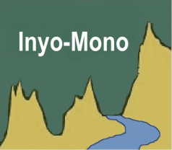
Date: Friday, January 19, 2018
1:00 – 3:00 pm PT

Conference call

Admin. Committee Members must send call-in location
to Holly by Wednesday, January 17, and post agenda at location

Call-in:
866-210-1669
passcode: 6194641

Call-in locations

- Inyo County Water Department
135 South Jackson St.
Independence, CA

AGENDA

- Welcome and Introductions

- Public Comment

- Administrative Committee composition for 2018 and appointment of Chair and Vice-Chair

- Discussion of upcoming work through DACI grant

  - Hiring DAC coordinator
  - Office space
  - DAC TAC
  - Role of Admin. Committee
  - Tasks not covered under DACI grant

- Adjourn

